VOCABULARY LIST MONSTER
Tier I

1. objection
2. overruled
3. sustained
4. felony
5. testimony
6. suspect
7. shackle
8. allege
9. prosecutor
10. defendant
11. defense
12. evidence
13. character
14. conviction
15. conviction

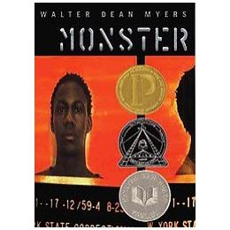

VOCABULARY LIST MONSTER
Tier II

1. soliciting
2. compassionate
3. potential
4. taint
5. alleged
6. acquit(ed)
7. reformatory
8. montage
9. mosaic
10. whist
11. diminutive
12. manslaughter
13. parole
14. hurdy-gurdy
15. felony

VOCABULARY LIST MONSTER
Tier III

1. merchandise
2. evidence
3. fringe
4. implicated
5. indulging
6. acquaintance
7. perpetrator
8. menace
9. implicate
10. technician
11. verdict
12. accusation
13.transverse
14. consign
15. felony

