Symbolism, Theme, and Conflict
Speak by Laurie Anderson
Directions: Fill in the graphic organizers using textual evidence from the novel.
Symbolism
Object | Representation | What we know about it | What is symbolizes
Melinda’s Lips

Trees | 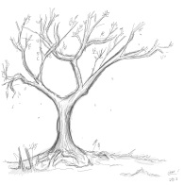
Closets

Mirrors

Theme
Theme | How does it tie to the book? | What is the author teaching us?
Isolation

Friendship

Guilt and Blame

Personal Transformation

Conflict
Type of Conflict | Example from Novel | Personal Connection
Man vs. _________

Man vs. _________

Man vs. _________

Man vs. _________

Man vs. _________

Man vs. _________

Man vs. _________

Man vs. _________

