Speak Character Analysis
Purpose: This page is intended for your notes on the character we meet. Fill out the graphic organizer by giving one example of direct characterization and one example of indirect characterization.
Name | Character |  | Character Description | Direct Characterization | Indirect Characterization
Melinda Sordino

Mr. Freeman

David Petrakis

Andy Evans | 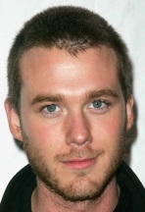
Heather

Rachel/Rachelle

Ivy | NO PICTURE
Nicole

Hairwoman | 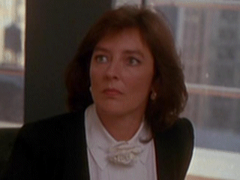
Mr. Neck | 