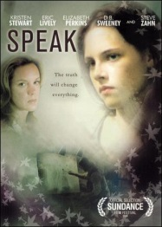
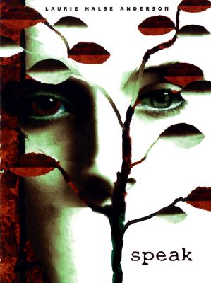
Speak: Compare and Contrast
Novel vs. Book

Directions: After watching the movie, complete the Venn diagram comparing and contrasting (5) events or details from the book and the movie. Then, answer the questions at the bottom of this page.
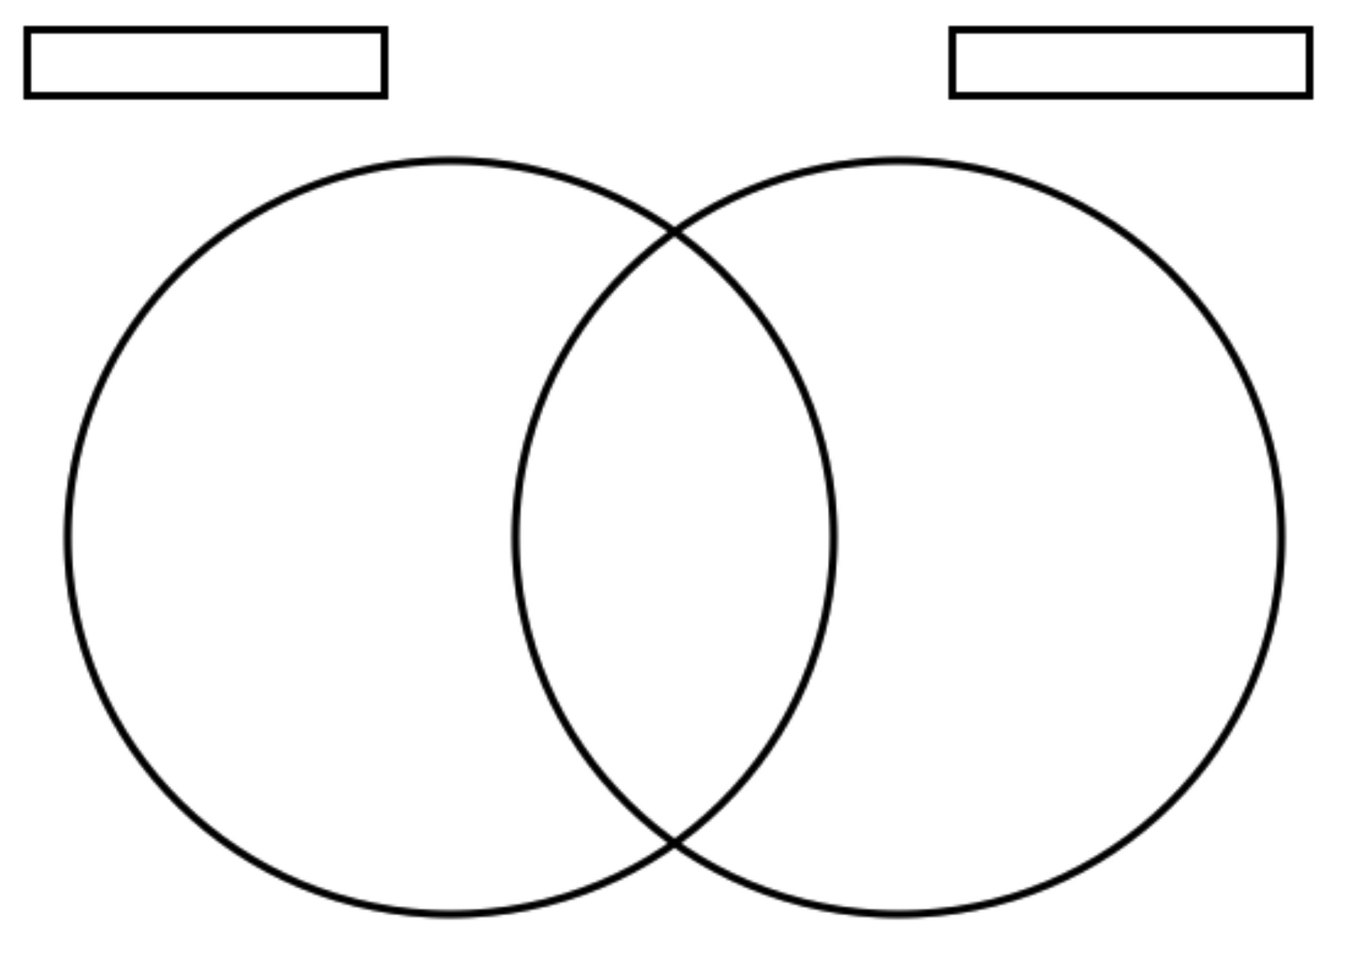

Answer the following questions on the back of this paper or a separate sheet:

1. Whom would you select to play the major roles such as Melinda, Andy, and Mr. Freeman in a movie version of Speak? Explain your choices.

2. Did you prefer imagining the scenes as you read the book or viewing the settings in the film? Why?

3. What character differed most dramatically from the way you imagined him or her in the book? Why do you think that character was changed in the movie version? Do you like or dislike the change? Explain.

