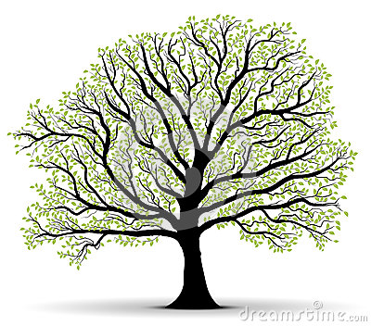

**Rubric**

1. Tree Artwork
   1. Creativity _____/ 10 points
   2. Detail _____/ 10 points
2. Explanation
   1. One page _____/ 5 points
   2. Analysis (description) _____/ 10 points
   3. Grammar and spelling _____/ 5 points

**Due Date:**

**Directions:**

This is a very reflective project. You will not be able to just skim by and do it in one day. You need to first understand yourself and the feelings you have in order to convey them in your piece of artwork. You will be creating a tree that symbolizes you. There are no strict guidelines you need to follow. The one requirement is that you must be able to explain how your tree represents you. Melinda worked on her piece of art for weeks. You need to begin planning and working on this now. You can use any type of materials you want (drawing, painting, collage through photography, paper mache, wood, clay, or anything else you want to do). You need to take this project seriously. ***It needs to be extremely detailed and should look like you spent multiple days planning and creating your piece of artwork.*** You then need to type a one page reflection and explanation about your piece of artwork. Take time to really reflect on how you are feeling with events going on in your life and show this in your paper.

Speak Final Project