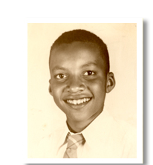
About Walter Dean Myers

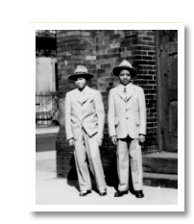
Walter age 11
“I was born on a Thursday, the 12th of August, _______, in Martinsburg, ________ ____________. My name at birth was ____________ ____________ __________. I was about ______ years old when my mother died and then I was inexplicably given to Florence and Herbert Dean. I was raised in ____________ by Herbert, who was African-American and Florence, who was German and Native American and wonderful. They loved me very much and I grew to love Harlem.
Walter and his brother Mickey grew up in Harlem
As a child, my life revolved around my neighborhood and church. The neighborhood protected me and the church guided me. I resisted as much as I could. I was smart (all kids are smart) but didn’t do that well in school. I had a speech impediment and often found myself leading with my fists when teased.
I found solace in __________. My mother read to me from a very young age. From my comfortable perch on her lap, I would watch as she moved her finger slowly across the page and I’d imagine the ____________________. Reading pushed me to discover worlds beyond my landscape, especially during dark times when my uncle was ________________ and my family became dysfunctional with alcohol and grief.
I wrote well in high school and an English teacher (bless her!) recognized this and advised me to keep on ______________ no matter what happened to me. “It’s what you do,” she said. I ended up ________________ out of high school (although now Stuyvesant High claims me as a graduate) and joined the army on my 17th birthday.
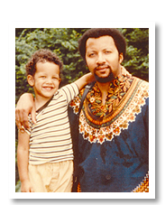
Christopher would one day illustrate books for his father.
After the army, I was ____________________ through life—holding on just enough to ______________. Remembering my high school teacher’s words, I began writing at __________. I wrote short columns for a local tabloid and stories for men’s magazines.
A turning point for me was the discovery of a short story by __________ ______________ about the black urban experience. It gave me permission to write about my own experiences. Somehow I always go back to the most turbulent periods of my own life. I write books for the ________________ boy I once was, and for the boy who lives within me still. It’s what I do.”
— Walter Dean Myers

About the Author Video: Walter Dean Myers
Exit Ticket: Watch the video about Walter Dean Myers and answer the following questions using what you learned.
1. Where did Walter Dean Myers get the idea for this story?

2. Why does he feel it's important to write stories like Monster?

3. Do you feel like his story is relevant to teenagers today? Why?

